Employee Database User Guide

# Table of Contents

Starting the Database 1

Navigating the Interface 1-3

Special Features 3-4

# Starting the Database

The following steps detail how to download and then launch the Employee Database program.

1. Download the “Employeedb.zip” file.
2. Unzip and extract the files to an easily accessible location using a file extractor such as 7-zip (free) or WinRAR (commercial).
3. Navigate to the file containing the unzipped files.
4. Launch the database program by double-clicking on “Employeedb.jar”

The following window should appear.

# Navigating the Interface

The database program is split into three sections; the entry field section (A) the employee search section (B) and the employee table section (C).

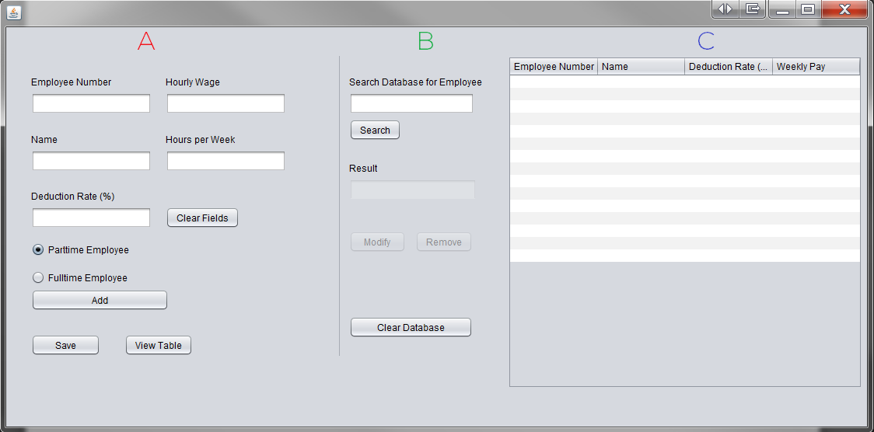

1. 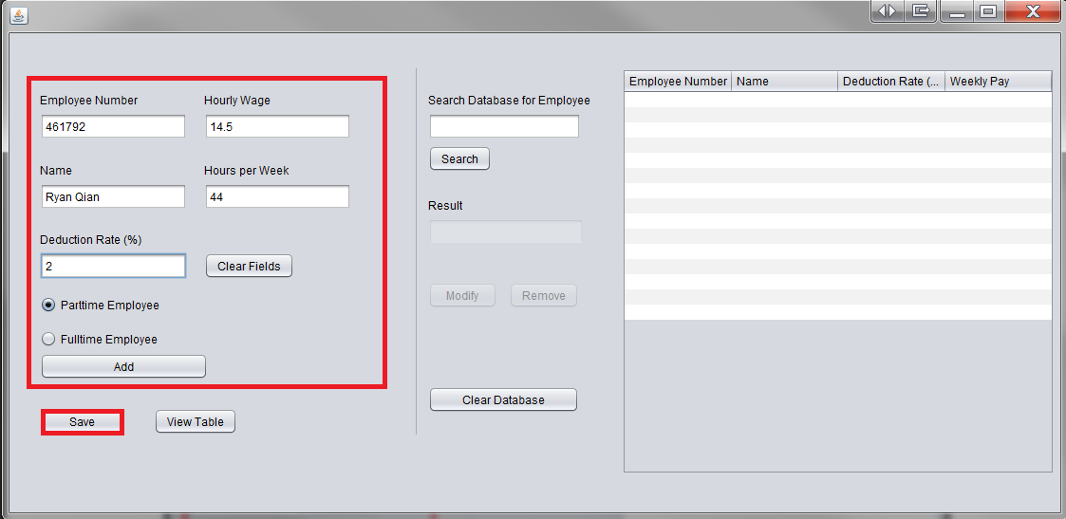This area contains all the information fields. They allow the user to enter all the pertinent employee data and add new employees. Simply enter the information in the appropriate text fields and indicate part/full time employment and then click “Add.” Note: Only enter appropriate information into the fields for a proper entry. Do not include any symbols or strange characters. A pop-up notice will appear after a successful addition. Once employees are added, click “Save” to store them in an archive file. A notification should popup confirming the save.
2. This area allows the user to search for existing employees in the hash table. Type in the employee number and then click “Search”. The result field will show the employee’s name if he/she is in the database; otherwise it will say “Not Found.”

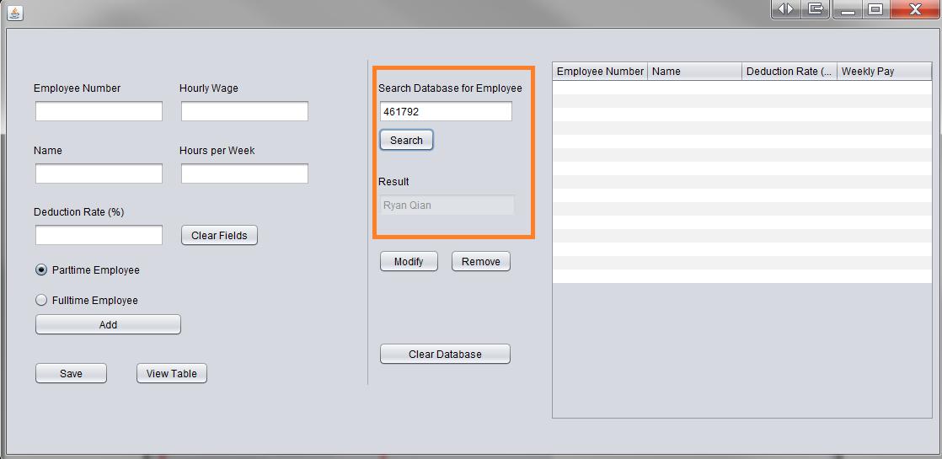

1. The employee table. After clicking “View Table” in the bottom left corner, the hash table will be loaded and all existing employees will be shown in the table on the right. Employee number, name, deduction rate, and weekly pay are shown.

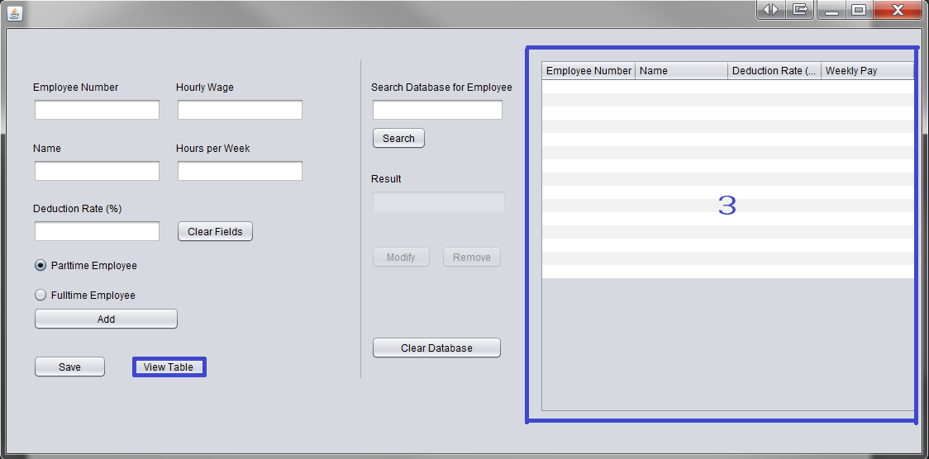

# Special Features

**Prompt for saving on exit**

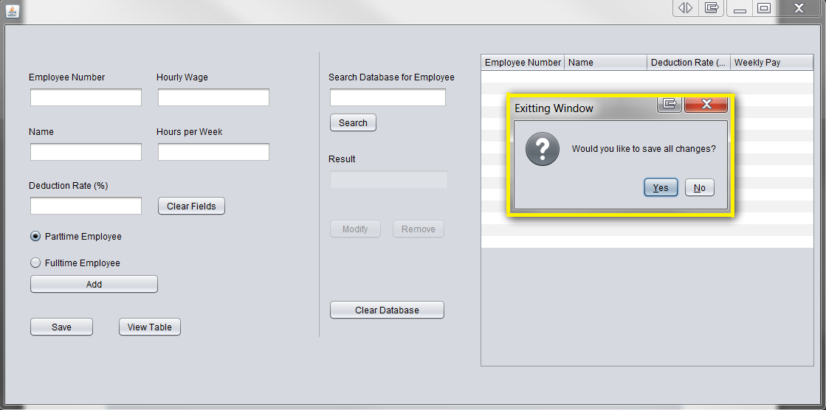Upon closing the program window, a prompt will ask if the user would like all changes to be saved into the archive file.

**Prompt for confirmation when clearing database**

After clicking the “Clear Database” button, a prompt will appear asking for confirmation.

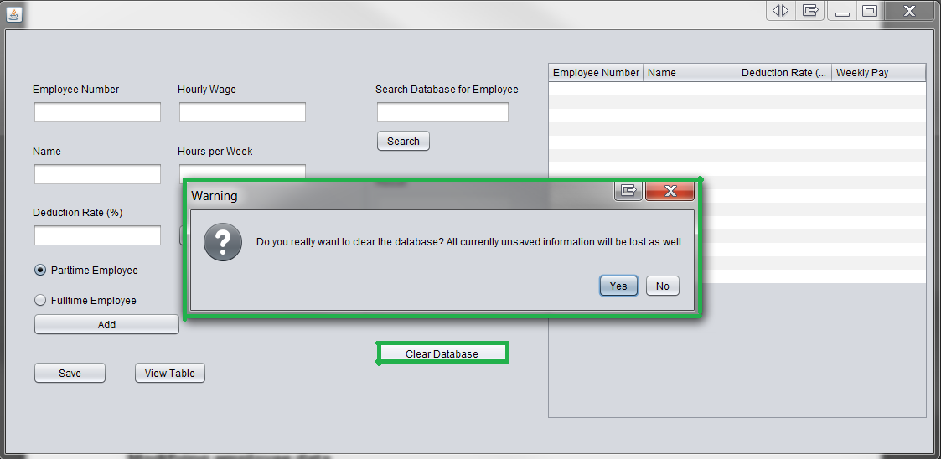

**Modifying employee data**

After searching and finding an employee in the hash table, the “Modify” button becomes enabled. This button brings up the employee information back to area (1) and allows for editing. After changes are complete, click “Change” to finalize the changes. Employees can also be simply removed with the “Remove” button.

